John Kiyak

CS 355

Program 3

One run of 10,000 cars:

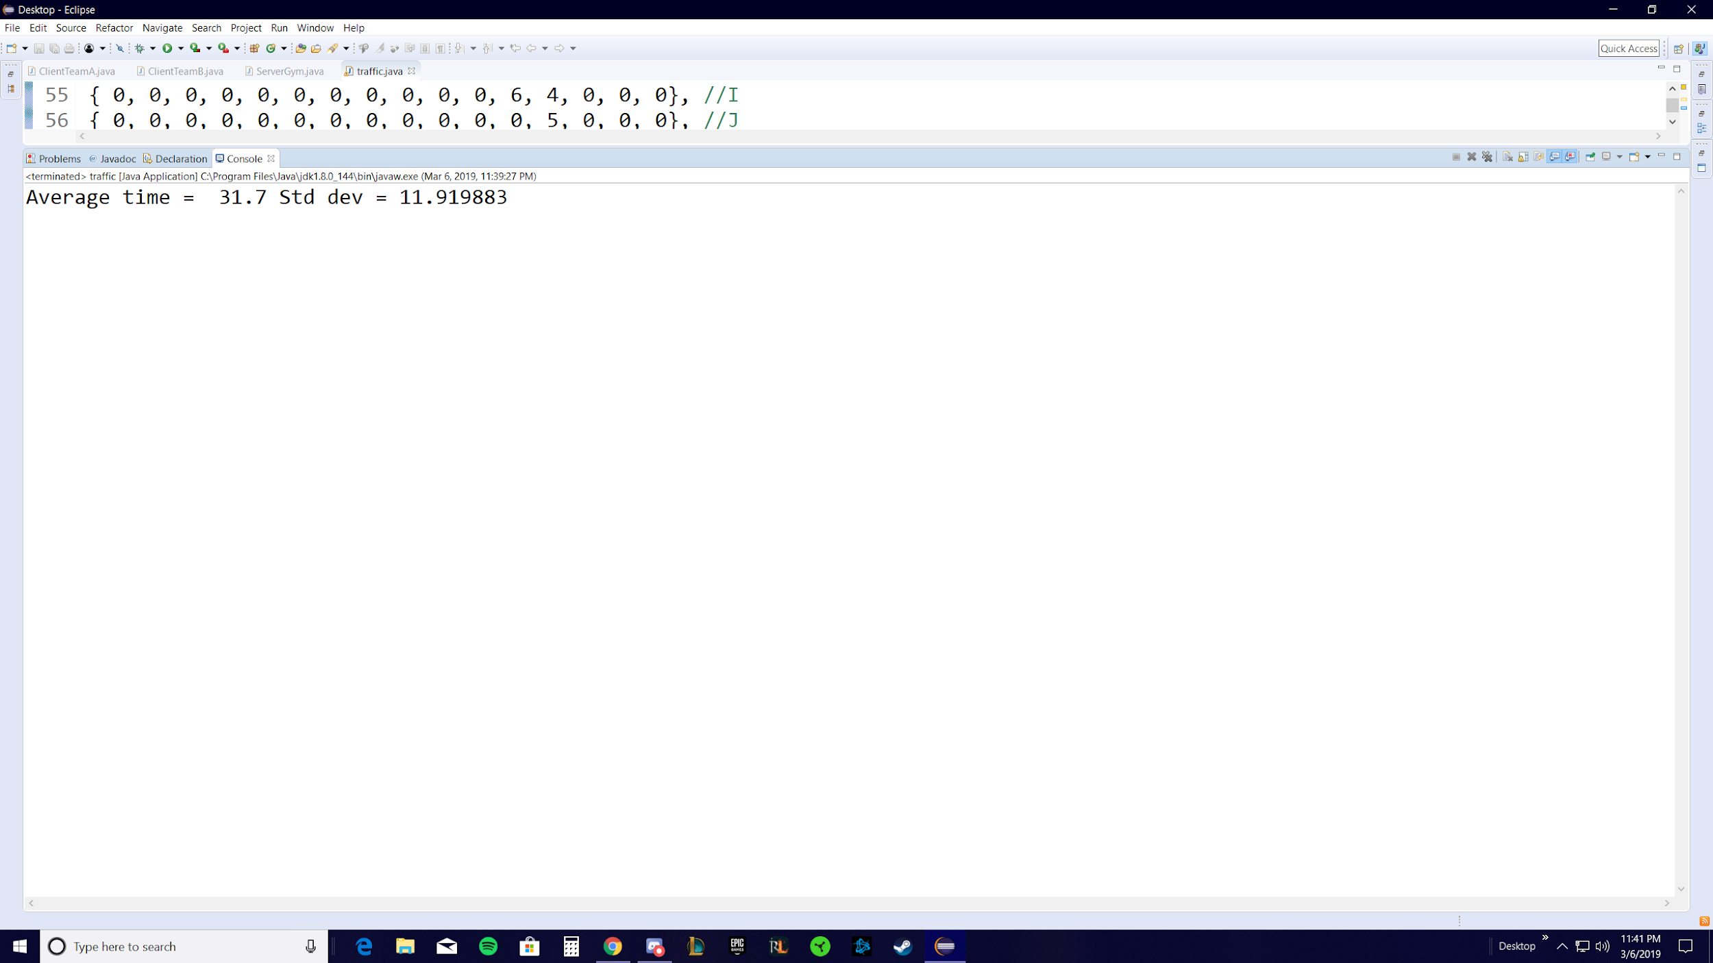

If you run the program 10 times, you get this output:

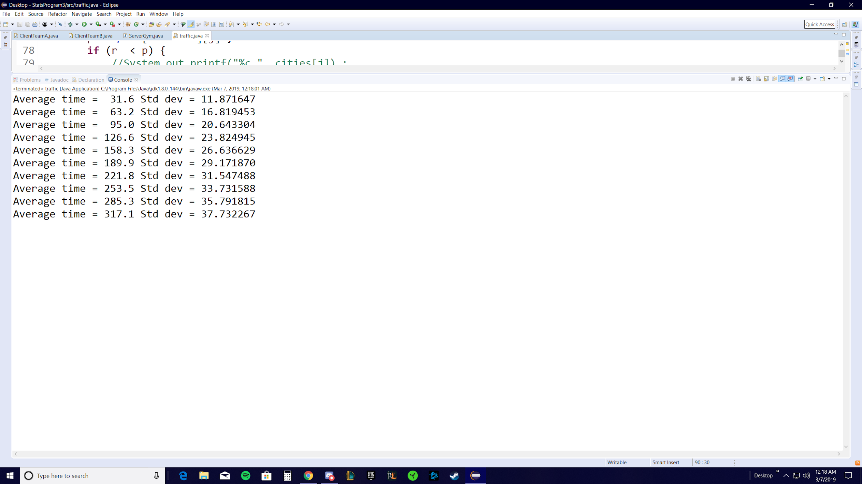

Running

